ASPIRE Mini Lessons
Middle School

About ASPIRE Mini Lessons:
ASPIRE mini lessons are short worksheets or games that can be used to help students learn more about a particular topic related to postsecondary education. These activities can be used in a classroom setting with a large or small group of students, used by ASPIRE mentors with their students, or students can use then on their own. They are adaptable based on setting, student level, or facilitator need.

The Middle School Collection:
The Middle School Collection of ASPIRE mini lessons contains a set of five lessons that focus on career exploration and introducing a variety of postsecondary pathways. To get the most out of these mini lessons it is suggested that the facilitator request an OSAC Options Beyond High School presentation or pre-teach a unit on postsecondary education.

Mini Lesson 1- Career Maze
Facilitation Difficulty: ☐ Easy ☐ Moderate ☒ Difficult
Type of Activity: ☐ Worksheet ☒ Game
Description- This is a career exploration activity. Students will complete two different mazes. At the end of the activity students will be matched with a career based on the choices they made in each maze. This activity is meant to be completed by students individually or in small groups and it includes some discussion questions for classes or mentor-student groups.

Mini Lesson 2- Career Crossword
Facilitation Difficulty: ☒ Easy ☐ Moderate ☐ Difficult
Type of Activity: ☐ Worksheet ☒ Game

Description- This activity uses a crossword puzzle to help students learn about a variety of careers in the healthcare, life and physical sciences, and art, media, and sports industries. The handout is meant to be completed by students, individually but could be modified for pair work. The activity includes some discussion questions for classes or mentor-student groups. Located within the instructions are activity modifications based on student level.

Mini Lesson 3- College Map
Facilitation Difficulty: ☒ Easy ☐ Moderate ☐ Difficult
Type of Activity: ☒ Worksheet ☒ Game
Description- This activity helps students learn about different types of colleges and universities located in the state of Oregon. To complete this worksheet students will locate different colleges, including community colleges, public colleges and universities, and private colleges on a blank map. This activity can be completed independently by the student or together in a group. Level of difficulty can be modified based on student level.

Mini Lesson 4- Life After High School Infographics
Facilitation Difficulty: ☐ Easy ☒ Moderate ☐ Difficult
Type of Activity: ☒ Worksheet ☐ Game
Description- This activity uses flowcharts and infographics to help students learn about a variety of postsecondary educational opportunities including apprenticeships, colleges and universities, community colleges, and military service. It can be completed independently or in groups. It is easily adaptable based on various student needs.

Mini Lesson 5- This or That?
Facilitation Difficulty: ☒ Easy ☐ Moderate ☐ Difficult
Type of Activity: ☒ Worksheet ☐ Game

Description- This worksheet helps students learn more about a variety of postsecondary options including apprenticeships, colleges and universities, community colleges, and military service. Students will be given information about a postsecondary option and will make a selection based on the information they received.

Using Mini Lessons:
Each mini lesson includes
- An instruction page that helps the facilitator understand how the activity is designed to be used
- Printable activity pages for student use
- Facilitator notes with ideas for modifications and extension activities.
Header
This includes suggested grade levels for the activity and approximately how long the activity takes to complete.

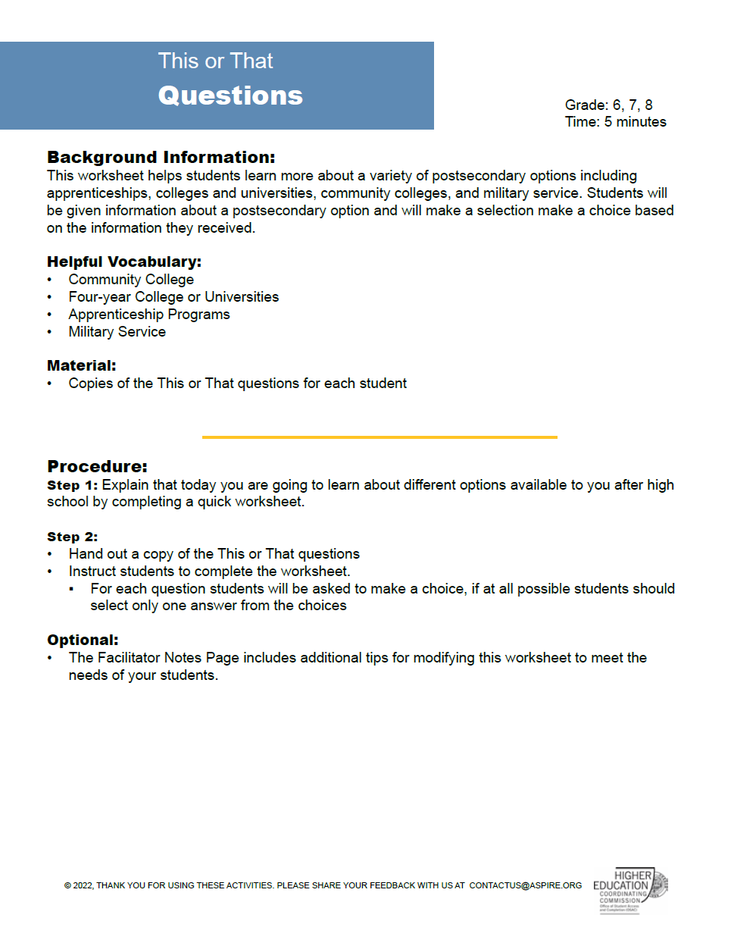
Facilitator Notes
A Facilitator Notes page is included at the end of the lesson and has suggestions for modifying the activity.
Procedure
This includes step by step instructions. Any handouts needed will included on the following pages.

Background Information:
This explains the purpose of the lesson.

A complete list of mini lessons and other helpful resources are located on our website: www.OregonStudentAid.Gov.

We are constantly adding additional min lessons so please continue to check our website for new content.

We hope you enjoy this collection of mini lessons.

The Activities

