MS Progress Report Instructions

Reports are due
- January15 (data between September-December)
- May 15 (data between January-May)

Student Participation

- Enrolled Students: Number of all students supported by your ASPIRE program.
These students do not need to have permission slips on file; however, coordinators should ensure that parents/guardians/caregivers are aware of student participation in ASPIRE activities. This number should never exceed the school total population. Enrolled students may include students who receive support through:
  - Classroom CCR presentations
  - Mentoring from volunteers, staff, and/or peers
  - Other career and college activities

Community and Staff Mentor Participation

- Traditional Mentors: Number of participating volunteer or site staff mentors.

- Episodic Volunteers: Number of volunteers, coordinator, or staff who provide career and college focused presentations, participate in job shadows, go on field trips to college campuses and participate in other ASPIRE activities. Volunteers help to direct conversations during events and discuss the relevance of each activity.

- Peer Mentors: Number of ASPIRE/HS students from nearby high school sites meet one-on- one or with groups of ASPIRE middle school students. Peer mentors can also include MS students (Ex. 8th grade students mentoring 6th grade students).

- Mentors that have Ended ASPIRE Service: Number of traditional (volunteer or staff) mentors who are no longer going to serve as mentors moving forward.

- Mentor Hours: Combined total number of hours contributed to ASPIRE by staff, episodic volunteers, or peer mentors.

- Trainings: Any mentor trainings for volunteer or peer mentors

- Participants: Number of total participants in trainings

Report Extension Required: ASPIRE MS CCR Inventory will gather site program related information that shows ASPIRE Career and College Readiness work at your site.

© Copyright 2022, Office of Student Access and Completion, All rights reserved. If you wish to make copies for educational purposes, contact the ASPIRE program at (541) 687-7400. www.OregonStudentAid.gov/aspire.aspx

Input Data into Partner Portal

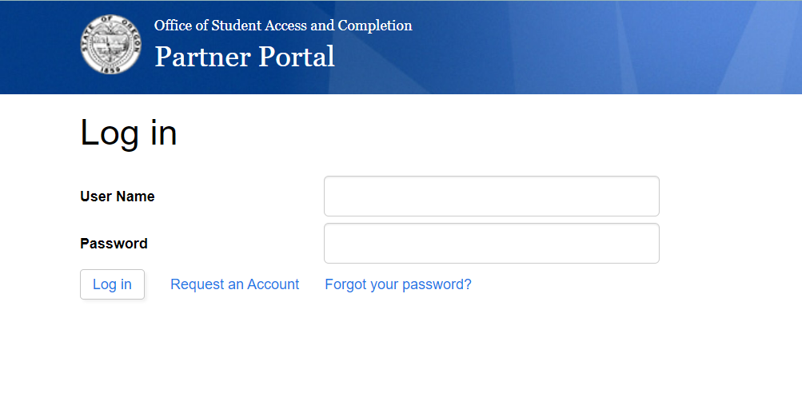
- Click on: https://partners.oregonstudentaid.gov/Account/Login?ReturnUrl=%2F
- Enter your Username and Password
- Click on Progress Report in the ASPIRE section
- Select Participation Year and click search
- Enter data in the appropriate fields, and click “Add.” You may need to refresh the page in order to view the data you just entered.

© Copyright 2022, Office of Student Access and Completion, All rights reserved. If you wish to make copies for educational purposes, contact the ASPIRE program at (541) 687-7400. www.OregonStudentAid.gov/aspire.aspx

