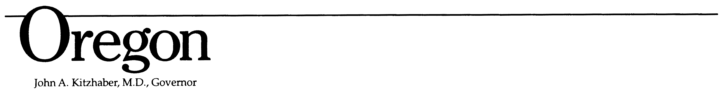
Higher Education Coordinating Commission
3225 25th St SE
Salem, OR 97302
Phone: 503-378-5690



Authorization and Release

The undersigned authorizes the Oregon Higher Education Coordinating Commission (HECC), and advertising agencies and their successors, assigns and nominees to use and reproduce the name, picture, portrait, film, photograph, video or voice of the undersigned in all forms and manners of media, in use and to be developed in the future.

The undersigned waives any right to inspect or approve any unfinished, altered or finished product that may be created in connection with their service.

The undersigned hereby releases the State of Oregon, HECC, its affiliates, advertising agencies, assigns and nominees from any and all claims for libel, slander, invasion of privacy or other claim based on the use of the undersigned’s service now and in the future.

Printed Name
Complete Address
Date
Signature

I am the parent or legal guardian of the minor named above and have the legal authority to execute the above release. I approve the foregoing and waive any rights in the premises.

Parent or Guardian Name

Complete Address
Date
Signature

